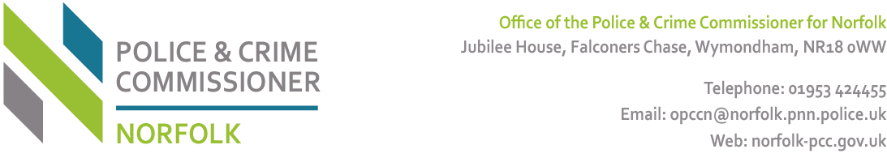

MONITORING FORM

All Local Policing Bodies are firmly committed to promoting equality of opportunity for all local people and communities, irrespective of gender, ethnic origin, disability, religious belief, sexual orientation, age or any other irrelevant factor. We therefore ask you to complete this questionnaire to enable us to monitor the effectiveness and fairness of our policy and processes.

This information is for statistical monitoring purposes only. IT WILL NOT FORM PART OF THE SELECTION PROCESS.

Ref No

A. GENDER (tick one box)
Male Female

B. ETHNIC GROUP - National Census Categories for England and Wales (tick one box)

How would you describe your ethnic origin?

WHITE |  | MIXED |  | ASIAN OR ASIAN BRITISH
British |  | White and Black Caribbean |  | Indian
Irish |  | White and Black African |  | Pakistani
Any other white background |  | White and Asian |  | Bangladeshi
 |  | Any other mixed background  Please specify: |  | Any other Asian background  Please specify:
BLACK AND BLACK BRITISH |  | CHINESE OR OTHER ETHNIC GROUP
Caribbean |  | Chinese
African |  | Any other Ethnic group  Please specify:
Any other black background
Please specify:

C. DISABILITY

Do you consider yourself to have a disability?
Yes No Prefer not to say

If yes, please describe your disability so that the Local Policing Body can make appropriate provision

D SEXUAL ORIENTATION

How would you describe your sexual orientation?

Bisexual |  | Heterosexual |  | Lesbian/Gay
Prefer not to say

E. RELIGION AND BELIEF (National Census Categories for England and Wales)

How would you describe your religious belief?

Buddhist |  | Christian |  | Hindu
Jewish |  | Muslim |  | Sikh
No Religion |  | Prefer not to say |  | Other:

F. LANGUAGE REQUIREMENTS

Do you have any language requirements you would like to tell us about?

Yes No
If yes, please tell us what these are:

THANK YOU FOR COMPLETING AND RETURNING THESE FORMS

